VALUE-CENTERS, L.L.C.

186 West Boulevard
Montgomery, AL 36108
334-265-6012 (OFFICE) 334-265-6024 (FAX)
www.value-centers.com

INSPECTION REPORT
A-2880
CUSTOMER: | Wells Fargo
DATE: | 05/03/12

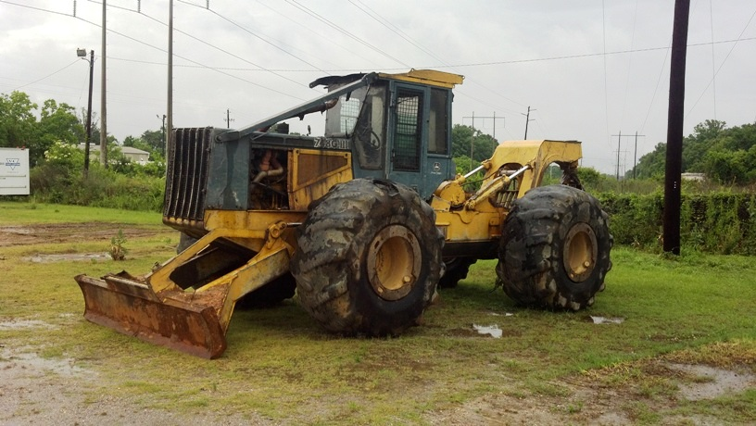

MACHINE DESCRIPTION:
Manufacturer: | John Deere | Serial Number: | DW748GX595065
Model: | 748GIII | Hour Meter: | 5,422
Type: | Single Arch Skidder | Cab: | Enclosed
Year: | 2005 | A/C: | Yes
Comments: The hour meter is questionable.

ATTACHMENTS:
Grapple: | Bunching | Blade: | 116in
Winch: | Deere
Comments: The winch cable is damaged.

GENERAL CONDITION: VERY GOOD: ( ) GOOD: ( ) FAIR: ( ) POOR: (X)
Sheet Metal: | Some Damage | Controls: | Some Damage
Paint: | Scratched / Rust | Frame: | Good
Glass: | Some Damage | Gauges: | Some Damage
Seat: | Good | Other:
Comments: Some of the engine panels are missing. The left side door is dented. The right windshield segment is damaged. The machine needs to be cleaned.

ENGINE:
Make: | Deere | Water in oil: | No
Starting ability: | Good | Leaks: | Some
Smoke: | Some | Radiator: | Dirty
Blow by: | Some | Battery Condition: | Missing
Oil Pressure: | Good | Charging System: | Good
Oil Level: | Good | Belts: | Worn
Belts: | Worn
Comments: One of the batteries is missing. There are several engine oil leaks. The engine needs to be serviced.

AXLES, PLANETARIES, DRIVELINE, BRAKES:
Brake Condition: | Good

HYDRAULIC SYSTEM:
Cylinders: | Some Leaking | Controls: | Some Damage
Rod condition: | Good | Leaks: | Some
Pump: | Good | Oil Level: | Low
Hoses: | Some Leaking | Other:
Comments: The machine has a major hydraulic oil leak under the cab. The machine is low on hydraulic oil.

LINKAGE:
Center pins: | Normal Wear | Cracks or Welds: | None Visible

TIRES:
Front Tire Size: | 30.5L-32 | Rear Tire Size: | 30.5L-32
Tread Percentage: |  | Other:
 | Comments:  All of the tires are heavily worn.
  0 | 0
  0 | 0

