VALUE-CENTERS, L.L.C.

186 West Boulevard
Montgomery, AL 36108
334-265-6012 (OFFICE) 334-265-6024 (FAX)
www.value-centers.com

INSPECTION REPORT
9-2471
CUSTOMER: | Wells Fargo
DATE: | 12/22/09

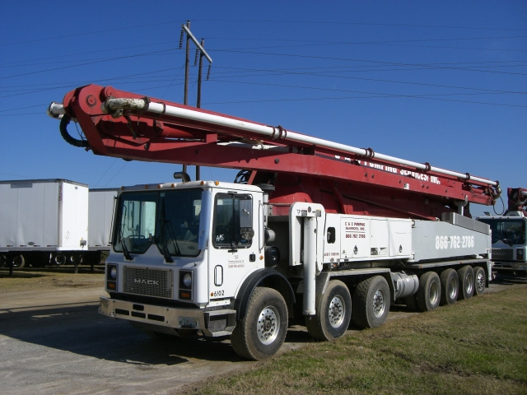

MACHINE DESCRIPTION:
Manufacturer: | Mack | Interior Color: | Gray
Model: | MR688S | Engine Make: | Mack
Type: | Concrete Pump Truck | Transmission: | Maxitorque ES
Year: | 2005 | Speed: | 10
VIN: | 1M2K201C35M027474 | Jake Brake: | Yes
Odometer: | 346,859 | Suspension: | Camelback & Air
Hour Meter: | 11,610 | A/C: | Yes
Cab Color: | White | Cruise: | Yes

ATTACHMENTS:
Make: | Schwing | Serial Number: | 107193
Year: | 2005 | Capacity: | 61 Meter
Type: | Concrete Pump | Pump Hour Meter: | 7,946
Model: | 2525-6 / S61SX

GENERAL CONDITION: VERY GOOD: ( ) GOOD: ( ) FAIR: (X) POOR: ( )
Sheet Metal: | Good | Controls: | Good
Paint: | Scratched | Frame: | Good
Glass: | Some Damage | Gauges: | Good
Seat: | Good | Remotes: | One Missing
Comments: The truck needs to be de-identified. The bumper is bent. The passenger side lower door glass is busted out. The battery powered remote is missing. The boom may need to be recertified in order to sell the unit.

HYDRAULIC SYSTEM:
Cylinders: | Good | Controls: | Good
Rod condition: | Good | Leaks: | N/A
Pump: | Good | Oil Level: | Good
Hoses: | Good | Other:

TIRES:
Front Tire Size: | 425/65R22.5 | Rear Tire Size: | 11R22.5
Tread Percentage: | (32nds) | Wheels: | Aluminum/Aluminum
 | Comments:
   | 15 | 13
   | 9 | 5
   | 10 | 17
  13 | 13 | 14 | 14
  14 | 15 | 15 | 15
  21 | 13 | 12 | 10
   | 17 | 13

