Value-Centers LLC.
Phone: 334-265-6012 Fax: 334-265-6024
186 West Blvd., Montgomery, Alabama 36108
www.value-centers.com Contact: Robert Preston email: rpreston@value-centers.com

INSPECTION REPORT
A-2570
CUSTOMER: | Wells Fargo
DATE: | 04/06/10

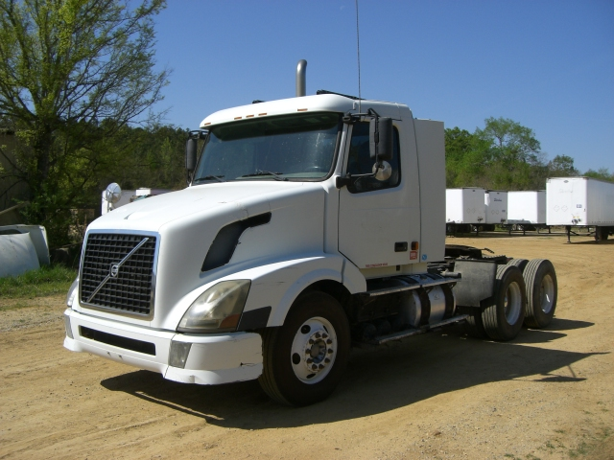

Year: | 2006 | Engine Make: | Volvo 12.1L
Make: | Volvo | Engine Model: | VE D12-395
Model: | VNM64T | HP: | 395
VIN: | 4V4NC9GG46N423927 | Engine Brake: | Yes
Miles/Hours: | 202,978 | Transmission: | Eaton Fuller
ECM Miles: | 202,978 | Speeds: | 10
Cab Color: | White | Axle: | Tandem
Interior Color: | Gray | Front Axle Cap: | 12,000
Trim Level: | Standard | Rear Axle Cap: | 38,000
Cab: | Air | Wheel Base: | 187in
Body Style: | Conventional | Tire Size: | 11R22.5
Suspension: | Air Ride | Front Wheels: | Steel
Frame: | Single | Rear Wheels: | Steel
5th Wheel: | Air Slide | Rear End Ratio: | 3.58
A/C: | Yes | Power Steering: | Yes
Air Shield: | Yes | Power Windows: | Yes
Dual Exhaust: | No | Power Locks: | No
Air Cleaners: | No | Dual Bunks: | No
High Back Seats: | Yes | Dual Gas Tanks: | No
Visor: | Yes | Sunroof: | No
Cruise Control: | Yes | AM/FM/Cassette: | Yes
Chrome Bumper: | No | Heated Mirrors: | No
Air Ride Seats: | Driver

Tread Depth Measurements (32nds) | Brakes Remaining (%)
Steer  25% | R1  25% | R2  25% | R3

 | 14 | 15
8 | 5 | 5 | 5
12 | 9 | 6 | 5

Damage and Repair Estimate

In Cab / Glass
The windshield is cracked. The rear cab window is cracked. The interior needs to be cleaned and detailed.

Outside
The bumper is damaged. The quarter fenders are damaged. The mud flaps are missing. The hood has fiberglass damage in several areas. The truck needs to be cleaned.

Engine & Drive Train
The engine needs to be serviced and cleaned. The batteries are dead and need to be replaced. There are multiple air leaks throughout the trucks. The clutch needs to be adjusted or replaced. There is a major vibration in the engine.

Tires & Brakes
Some of the tires are heavily worn. The brakes and drums are heavily worn.

