VALUE-CENTERS, L.L.C.

186 West Boulevard
Montgomery, AL 36108
334-265-6012 (OFFICE) 334-265-6024 (FAX)
www.value-centers.com

INSPECTION REPORT
9-2498
CUSTOMER: | Wells Fargo
DATE: | 01/05/09

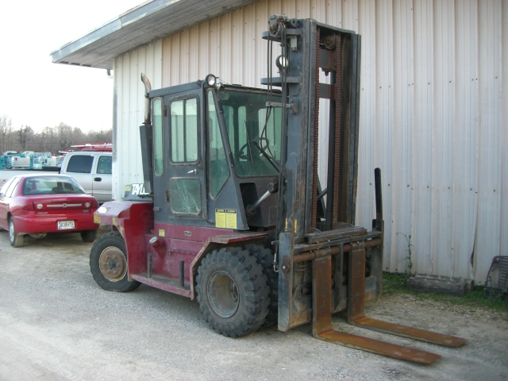

MACHINE DESCRIPTION:
Manufacturer: | Taylor | Cab: | Enclosed
Model: | THD-160 | A/C: | No
Type: | Fork Lift | 4x4: | No
Year: | 2005 | Machine Weight: | 22,650 lbs
Serial Number: | SC8-32552 | Machine Capacity: | 16,000 lbs
Hour Meter: | 8,930 | Mast: | 11ft – 2 Stage

ATTACHMENTS:
Type: | Forks | Size: | 47in L , 9.5in W

GENERAL CONDITION: VERY GOOD: ( ) GOOD: ( ) FAIR: (X) POOR: ( )
Sheet Metal: | Some Damage | Controls: | Good
Paint: | Rusted / Scratched | Frame: | Good
Seat: | Torn | Gauges: | Good
Comments: The front windshield is cracked. The rear cab glass is cracked. The left and right lower door glass is damaged. The rear grill is damaged. The machine needs to be cleaned.

Engine:
Make: | Cummins | Belts: | Worn
Model: | B4.5T-99 | Water in oil: | N/A
HP: | 99 | Leaks: | No
Starting ability: | Good | Radiator: | Dirty
Smoke: | No | Battery Condition: | Good
Blow by: | No | Charging System: | Good
Oil Pressure: | Good | Oil Level: | Good
Comments: The machine will not crank or operate. The engine needs to be cleaned and serviced.

HYDRAULIC SYSTEM:
Cylinders: | Good | Controls: | Good
Rod condition: | Good | Leaks: | Some
Pump: | Good | Oil Level: | Good
Hoses: | Some Leaking | Other:
Comments: There are several hydraulic leaks throughout the machine.

TIRES:
Front Tire Size: | 8.25R15 | Rear Tire Size: | 8.25R15
Tread Percentage: |  | Other:
 | Comments:  The left rear tire is heavily worn.
  70 | 70 | 70 | 70
   | 0 | 10

